Day 3
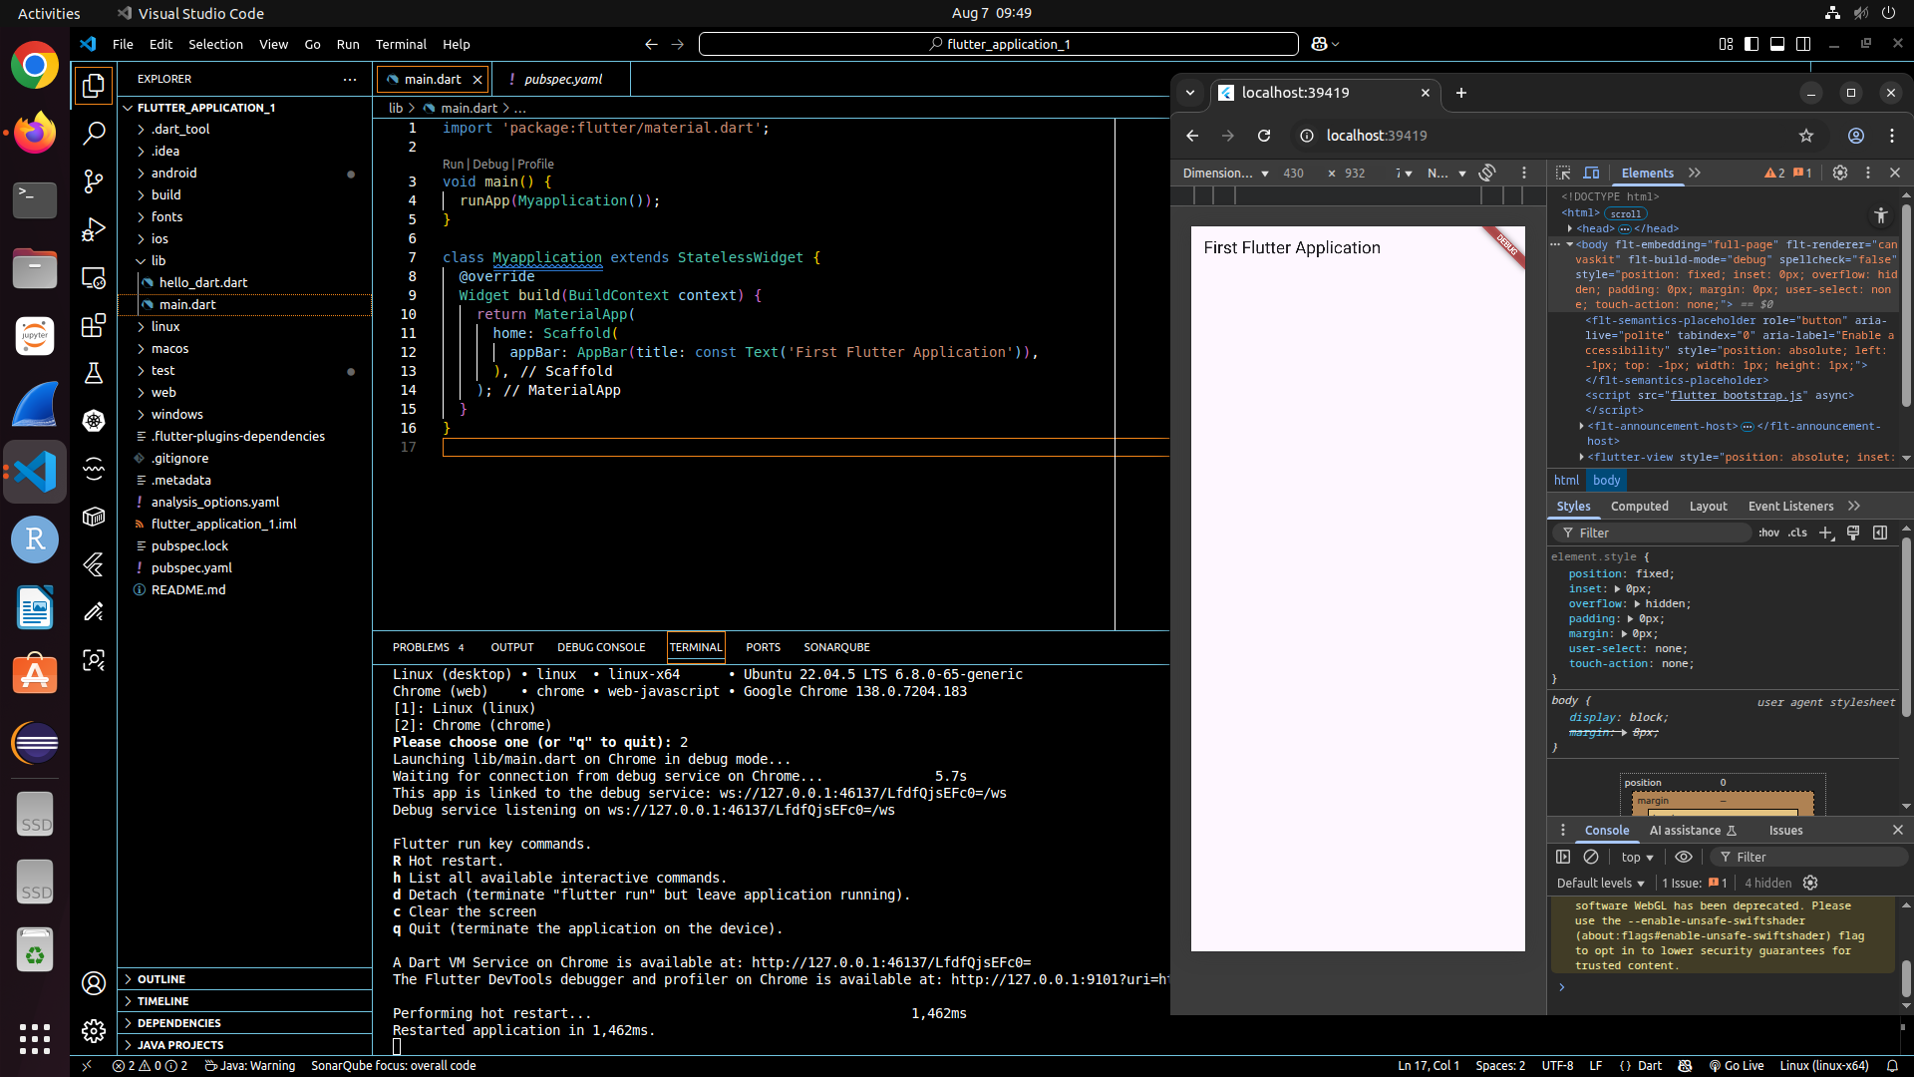
Drawer header
import 'package:flutter/material.dart';

void main() => runApp(MyApp());

class MyApp extends StatelessWidget {
@override
Widget build(BuildContext context) {
return MaterialApp(
home: Scaffold(
appBar: AppBar(title: Text('Drawer Example')),
drawer: Drawer(
child: ListView(
padding: EdgeInsets.zero,
children: <Widget>[
DrawerHeader(
decoration: BoxDecoration(color: Colors.blue),
child: Text(
'Drawer Header',
style: TextStyle(color: Colors.white, fontSize: 24),
),
),
ListTile(
leading: Icon(Icons.home),
title: Text('Home'),
onTap: () => Navigator.pop(context),
),
ListTile(
leading: Icon(Icons.settings),
title: Text('Settings'),
onTap: () => Navigator.pop(context),
),
ListTile(
leading: Icon(Icons.pending),
title: Text('Edit'),
onTap: () => Navigator.pop(context),
),
],
),
),
body: Center(child: Text('Drawer Example App')),
),
);
}
}

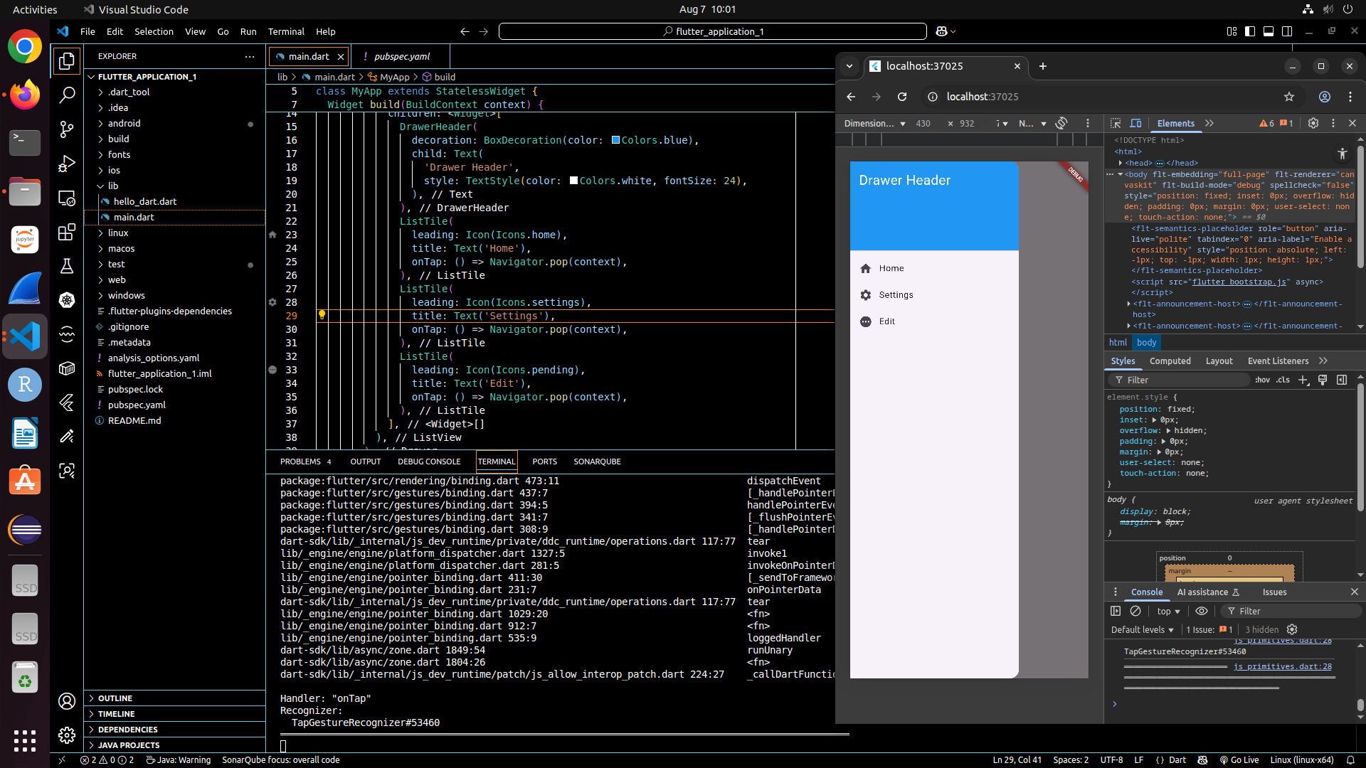
Action button
import 'package:flutter/material.dart';

void main() => runApp(MyApp());

class MyApp extends StatelessWidget {
@override
Widget build(BuildContext context) {
return MaterialApp(
home: Scaffold(
appBar: AppBar(title: Text('Drawer & FAB Example')),
drawer: Drawer(
child: ListView(
padding: EdgeInsets.zero,
children: <Widget>[
DrawerHeader(
decoration: BoxDecoration(color: Colors.blue),
child: Text(
'Drawer Header',
style: TextStyle(color: Colors.white, fontSize: 24),
),
),
ListTile(
leading: Icon(Icons.home),
title: Text('Home'),
onTap: () {
Navigator.pop(context); // close drawer
},
),
ListTile(
leading: Icon(Icons.settings),
title: Text('Settings'),
onTap: () {
Navigator.pop(context); // close drawer
},
),
],
),
),
body: Center(child: Text('Press the button below!')),
floatingActionButton: FloatingActionButton(
onPressed: () {
print('Button Pressed!');
},
child: Icon(Icons.add),
backgroundColor: Colors.blue,
tooltip: 'Add',
),
),
);
}
}

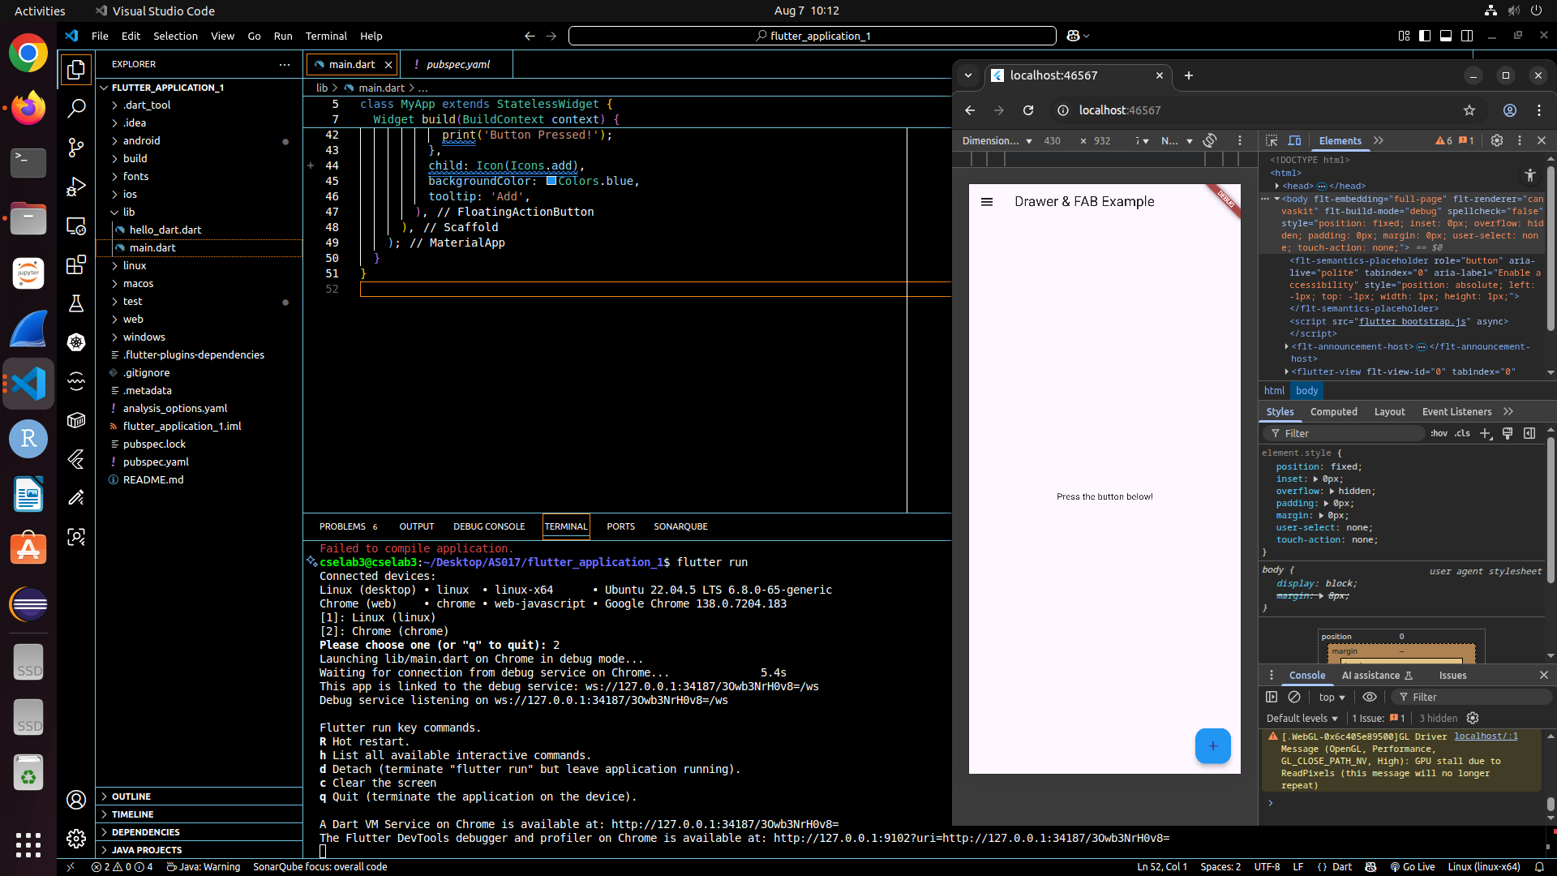
import 'package:flutter/material.dart';

void main() => runApp(MyApp());

class MyApp extends StatelessWidget {
@override
Widget build(BuildContext context) {
return MaterialApp(
home: Scaffold(
appBar: AppBar(title: Text('Container Example')),
body: Center(
child: Container(
width: 200.0,
height: 100.0,
padding: EdgeInsets.all(35),
margin: EdgeInsets.all(20),
alignment: Alignment.bottomRight,
transform: Matrix4.rotationZ(0.1),
child: Text(
"Hello! I am in the container widget",
style: TextStyle(fontSize: 25),
),
),
),
),
);
}
}

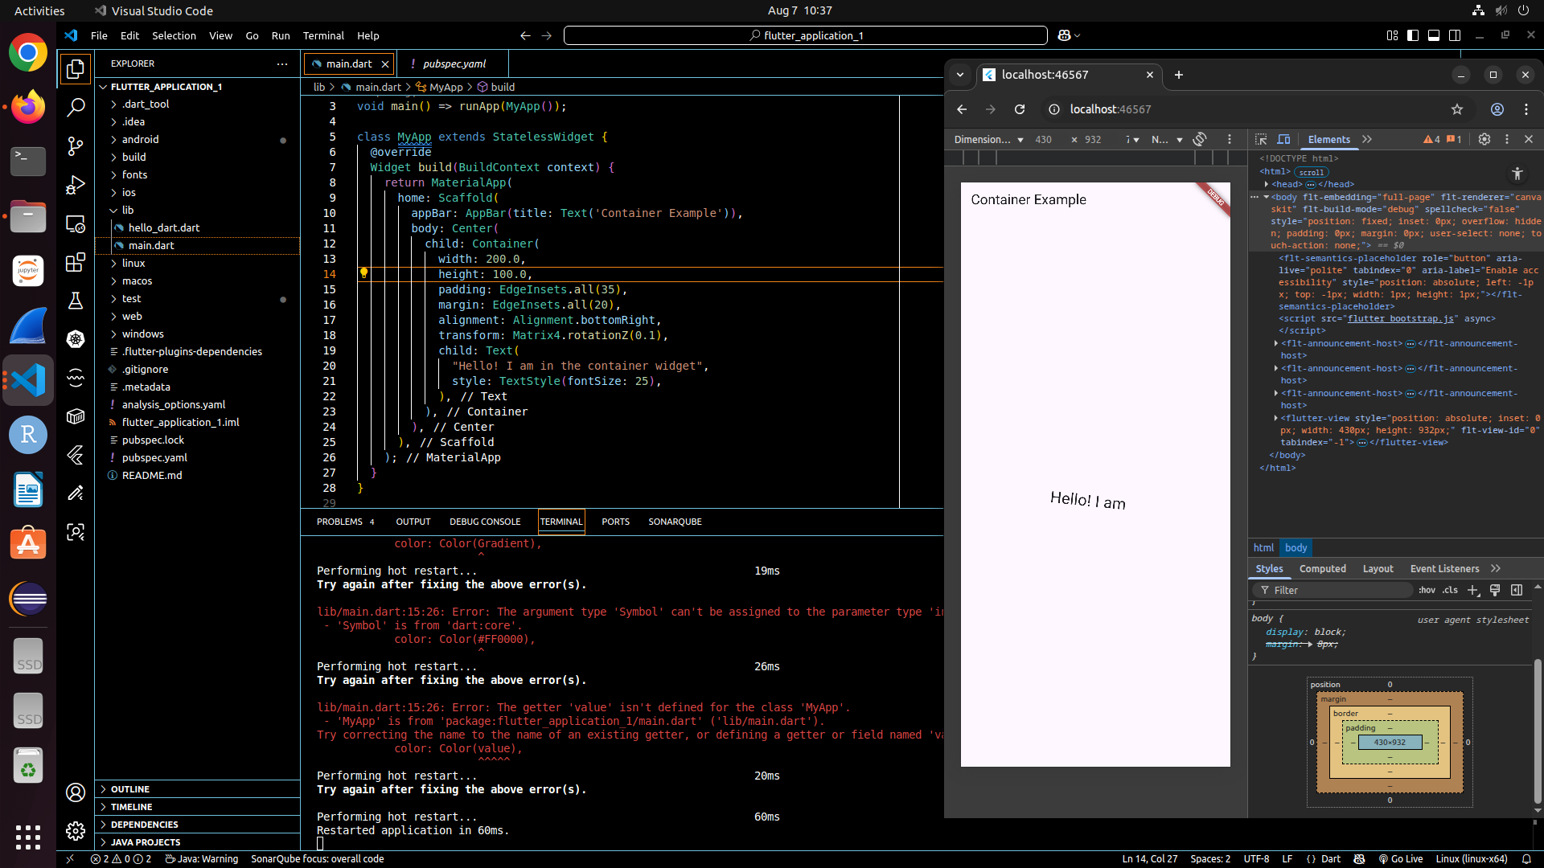
Constraints
import 'package:flutter/material.dart';

void main() => runApp(MyApp());

class MyApp extends StatelessWidget {
@override
Widget build(BuildContext context) {
return MaterialApp(
home: Scaffold(
appBar: AppBar(
title: Text('Constraints Example'),
),
body: Center(
child: Container(
constraints: BoxConstraints(
minWidth: 100,
maxWidth: 200,
minHeight: 100,
maxHeight: 200,
),
color: Colors.blue,
child: Center(
child: Text(
'Constrained Container',
style: TextStyle(
color: Colors.white,
fontSize: 18,
),
),
),
),
),
),
);
}
}
import 'package:flutter/material.dart';

void main() => runApp(MyApp());

class MyApp extends StatelessWidget {
@override
Widget build(BuildContext context) {
return MaterialApp(
home: Scaffold(
appBar: AppBar(
backgroundColor: Colors.blue,
title: Text('Row Widget Example'),
centerTitle: true,
),
body: Padding(
padding: const EdgeInsets.all(24.0), // padding from all edges
child: LayoutBuilder(
builder: (context, constraints) {
// Available width inside the padding
double totalSpacing = 16 * 2; // spaces between boxes
double boxSize = (constraints.maxWidth - totalSpacing) / 3;

return Center(
child: Row(
mainAxisSize: MainAxisSize.min,
children: [
Container(
width: boxSize,
height: boxSize,
color: Colors.red,
),
SizedBox(width: 16),
Container(
width: boxSize,
height: boxSize,
color: Colors.green,
),
SizedBox(width: 16),
Container(
width: boxSize,
height: boxSize,
color: Colors.blue,
),
],
),
);
},
),
),
),
);
}
}

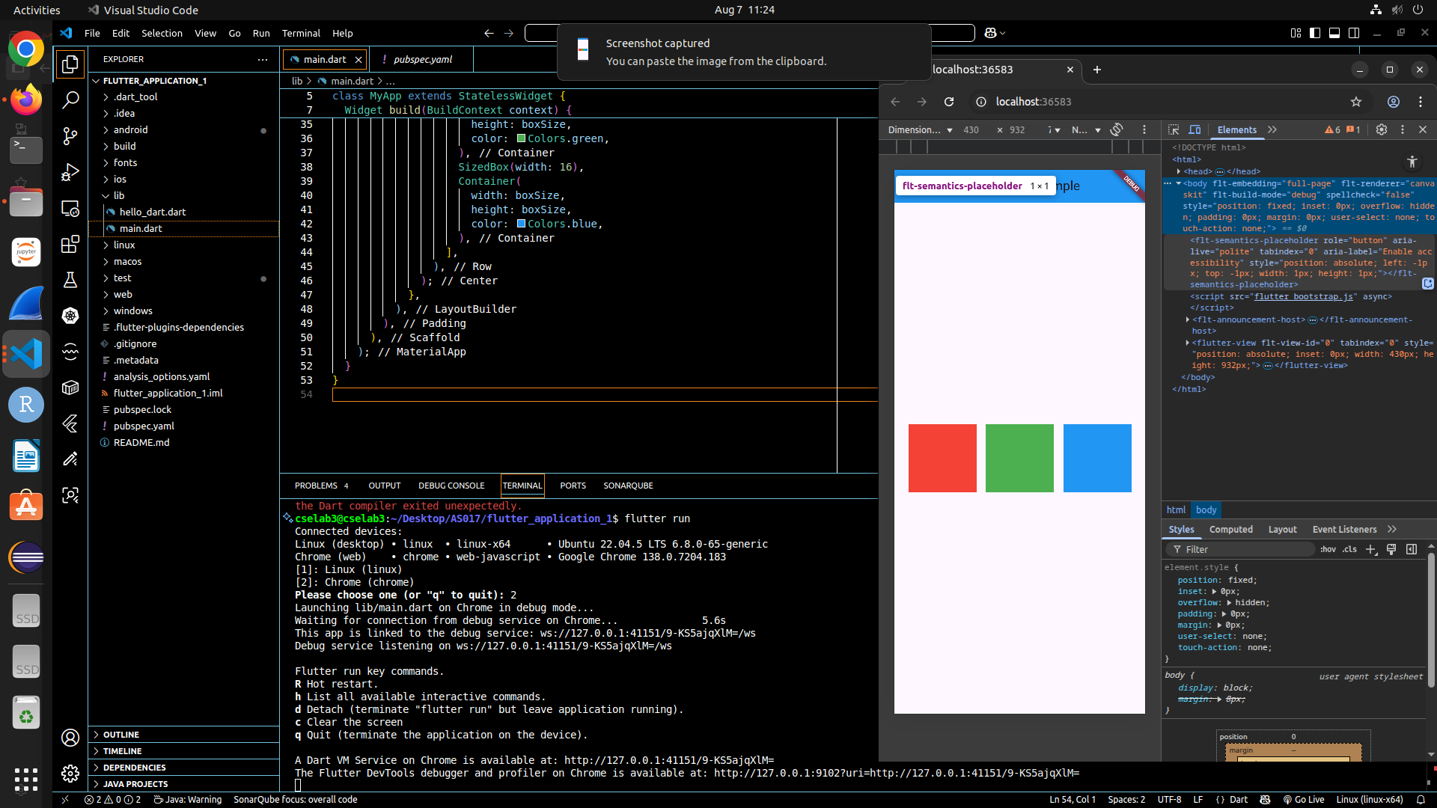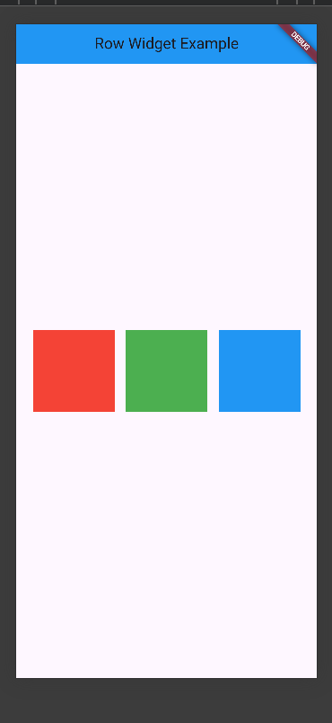
import 'package:flutter/material.dart';

void main() => runApp(MyApp());

class MyApp extends StatelessWidget {
// Replace with your local image asset path
final String profileImagePath = '/home/cselab3/Desktop/AS017/flutter_application_1/ramaiah1.jpg';

@override
Widget build(BuildContext context) {
return MaterialApp(
home: Scaffold(
appBar: AppBar(
title: Text('Profile Example'),
backgroundColor: Colors.blue,
centerTitle: true,
),
body: Center(
child: Padding(
padding: const EdgeInsets.all(24.0),
child: Column(
mainAxisSize: MainAxisSize.min, // Center vertically with minimal height
crossAxisAlignment: CrossAxisAlignment.center,
children: [
// Profile photo circle
CircleAvatar(
radius: 60, // size of the circle
backgroundImage: AssetImage(profileImagePath),
backgroundColor: Colors.grey[200],
),
SizedBox(height: 16),

// Bold name
Text(
'Dr.M.S.Ramaiah',
style: TextStyle(
fontWeight: FontWeight.bold,
fontSize: 22,
),
textAlign: TextAlign.center,
),

// Subtitle
Text(
'Founder Chairman',
style: TextStyle(
fontSize: 16,
color: Colors.grey[700],
),
textAlign: TextAlign.center,
),

SizedBox(height: 24),

// Paragraph text
Text(
'Mathikere Sampangi Ramaiah was born on 20 April 1922, in Madhugiri to Sampangappa and Narasamma.',
style: TextStyle(fontSize: 16),
textAlign: TextAlign.center,
),
],
),
),
),
),
);
}
}

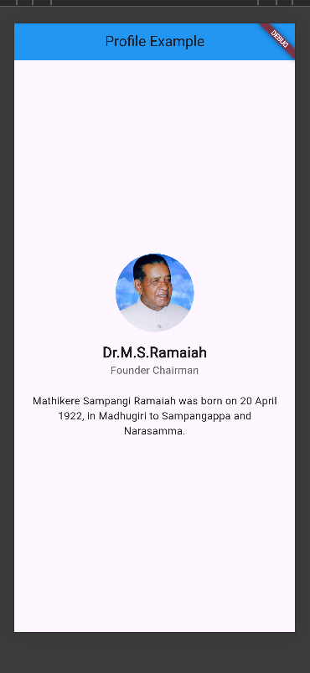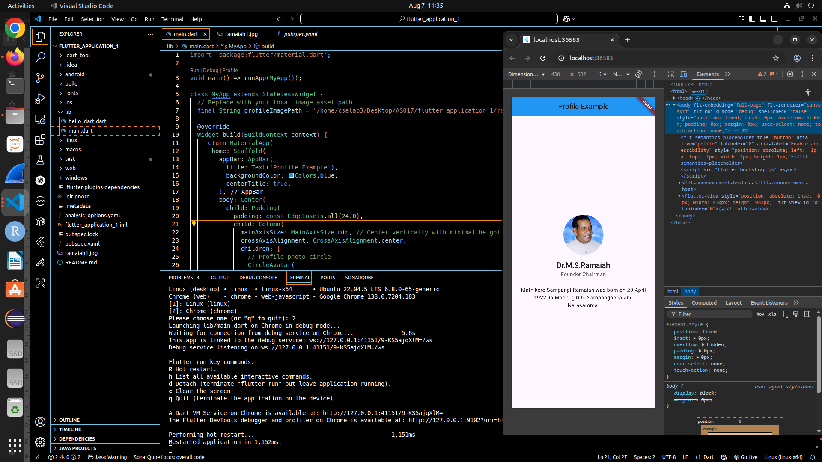
Exercise-3
import 'package:flutter/material.dart';

void main() {
runApp(MyApp());
}

class MyApp extends StatelessWidget {
@override
Widget build(BuildContext context) {
return MaterialApp(
home: Scaffold(
appBar: AppBar(
backgroundColor: Colors.blue, // Blue navbar
title: Text('TextButton Example'), // Updated heading
),
body: Center(
child: TextButton(
onPressed: () {
print('Button Clicked!');
},
child: Text(
'Click Me',
style: TextStyle(fontSize: 24),
),
),
),
),
);
}
}

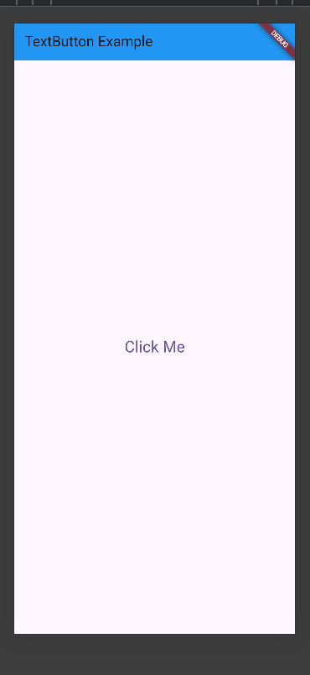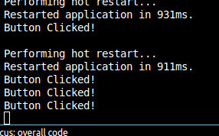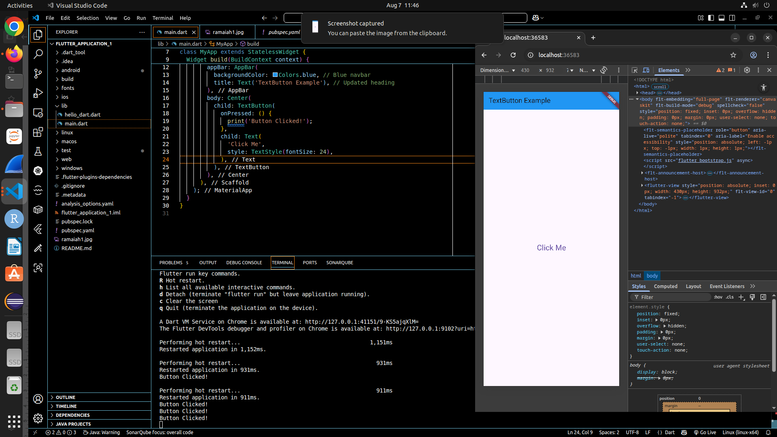
Elevated button
import 'package:flutter/material.dart';

void main() {
runApp(MyApp());
}

class MyApp extends StatelessWidget {
@override
Widget build(BuildContext context) {
return MaterialApp(
home: Scaffold(
appBar: AppBar(
backgroundColor: Colors.blue, // Blue AppBar
title: Text('TextButton Example'),
),
body: Center(
child: ElevatedButton(
onPressed: () {
print('Button Clicked!');
},
style: ElevatedButton.styleFrom(
backgroundColor: Colors.green, // Button color
padding: EdgeInsets.symmetric(horizontal: 24, vertical: 12),
textStyle: TextStyle(fontSize: 20),
),
child: Text('Click Me'),
),
),
),
);
}
}

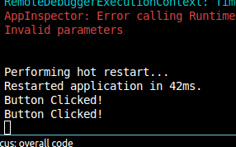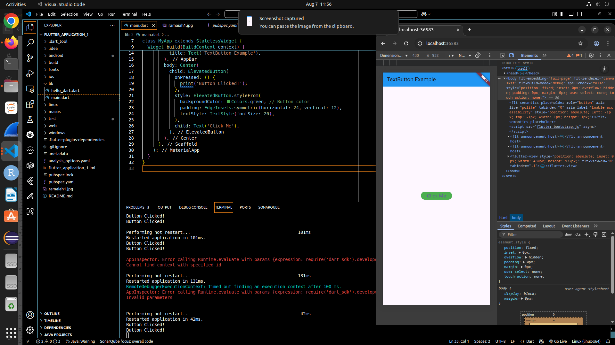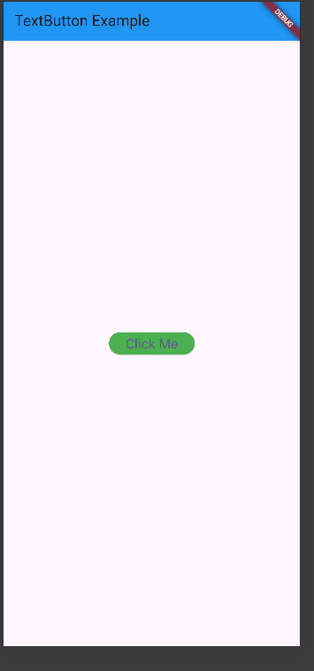
Outline button
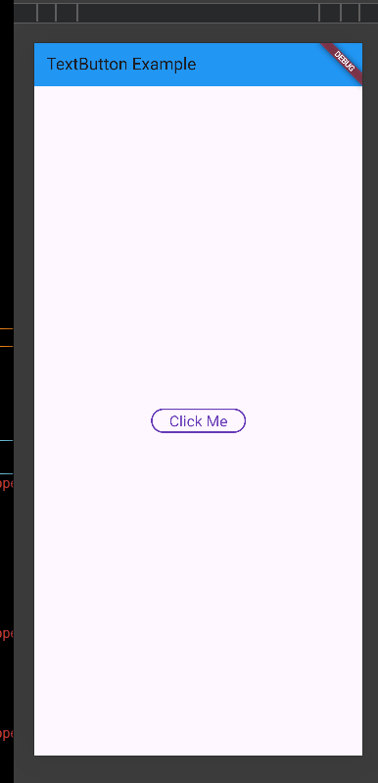
Alert button
